Protocol for genitourinary symptoms of menopause (GSM) Using Low-Intensity Shockwaves
Device: MoreNova - Li50F Linear Transducer
Document Version: 1.0
Date: 17/12/25
1
. Purpose and Scope
This protocol provides a standardized treatment plan for using low-intensity shockwaves to
manage Vaginal Atrophy / Genitourinary Syndrome of Menopause (GSM). It is intended for
healthcare providers using the MoreNova Device with the Li50F Transducer to target the Vaginal
wall – 6 angles (60° apart).
This protocol applies to women experiencing genitourinary symptoms of menopause (GSM),
including vaginal dryness, burning, or irritation. For further information on clinical studies and
eﬀicacy, visit our Clinical Data Center.
Device Overview:
MoreNova is a portable Electromagnetic (EM) Low-Intensity Shockwave (LISW) device designed to
reduce inﬂammation, dissolve calciﬁcations, and stimulate angiogenesis, improving outcomes for
various conditions in men and women.
2
. Introduction
Low-Intensity Extracorporeal Shockwave Therapy (LiESWT) is a non-invasive technology that uses
acoustic waves to promote vascularization, enhance blood circulation, and stimulate nerve
regeneration. It has been clinically shown to improve genitourinary menopausal symptoms by
targeting key vaginal and periurethral tissues involved in mucosal health, elasticity,
vascularization, and tissue regeneration.
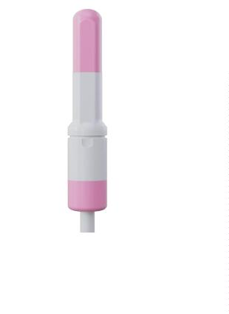

3
. Background Condition Overview:
•
•
•
Genitourinary Syndrome of Menopause (GSM) is a chronic condition associated with
estrogen deﬁciency, aﬀecting the vagina, vulva, urethra, and bladder.
It is characterized by vaginal dryness, burning, irritation, dyspareunia, and urinary
symptoms such as urgency, dysuria, and recurrent urinary tract infections.
These symptoms result from thinning of the urogenital epithelium, reduced
vascularization, decreased elasticity, and altered tissue integrity following menopause.
Mechanism of Action:
•
Low-intensity shockwave therapy is thought to stimulate biological responses including
neovascularization, improved microcirculation, and enhanced tissue oxygenation in the
treated vaginal and periurethral tissues.
•
These eﬀects may support tissue regeneration, improve mucosal health and elasticity,
and thereby contribute to relief of vaginal and urinary symptoms associated with GSM.

4
. Patient Selection Criteria Inclusion Criteria:
•
•
•
Females aged 40–75
Postmenopausal women diagnosed with vaginal atrophy or GSM
Experiencing symptoms such as vaginal dryness, irritation, itching, burning, or
painful intercourse (dyspareunia)
•
Symptoms persisting for ≥3 months despite use of moisturizers or lubricants
Exclusion Criteria:
•
•
•
•
•
•
•
Active vaginal or urinary tract infection.
Undiagnosed vaginal bleeding.
History of estrogen-dependent malignancy (e.g., breast or endometrial cancer).
Recent pelvic surgery or radiation therapy (<6 months).
Pregnancy or lactation.
Presence of implanted electronic or metal devices sensitive to electromagnetic radiation.
Severe vaginal prolapse or anatomical distortion preventing proper Transducer placement.
5
. Pre-Treatment Screening
To determine the patient's suitability for LiESWT, conduct the following:
•
•
•
Comprehensive medical and gynecologic history, including menopausal status, hormone
therapy use, and urinary symptoms.
Pelvic and genital examination to evaluate vaginal mucosa, tissue integrity, and signs of
atrophy or inﬂammation.
Diagnostic evaluation as indicated to exclude active infections, unexplained bleeding, or
structural/anatomical abnormalities of the genitourinary tract.
6
. Treatment Protocol Preparation:
•
Confirm findings from a comprehensive medical history and gynecological
examination, with attention to menopausal status and genitourinary symptoms.
•
Counsel the patient on the treatment procedure, anticipated benefits for GSM
symptoms, potential risks or discomfort, alternative treatment options, and realistic
expectations regarding outcomes.

Procedure:
•
•
•
•
•
•
Number of Sessions: 6 sessions
Session Frequency: Twice per week.
Session Duration: 25 minutes.
Applications Per Session: Vaginal wall – 6 angles (60° apart).
Shocks Per Application: 500.
Total Shocks Per Session: 3000.
Treatment Parameters:
•
•
Energy (HV) Settings: 2.0 kV.
Frequency (FRQ): 2 Hz.
Post-Treatment Care:
•
•
Advise patients to avoid vaginal intercourse and intravaginal products for 24 hours
following each treatment session.
Encourage adequate hydration and instruct patients to report any unexpected
discomfort, irritation, bleeding, or other adverse events to their healthcare provider.
7
. Treatment Areas and Techniques
The treatment focuses on the following anatomical areas:
•
Vaginal canal (Vaginal wall)
The rotation pattern:
•
-180
-120
-60
0
•
•
•
•
•
•
60
120
180
Transducer Placement:
•
Apply the Transducer gently to the designated areas, using conductive gel to facilitate
energy transfer.

•
•
Gentle internal application with continuous coupling gel, along the vaginal wall, rotating
the transducer to six angles
Deliver 500 shocks to each application area, following the predeﬁned sequence.
8
. Patient Comfort and Safety
To ensure patient comfort and safety during the procedure:
•
•
•
•
Position the patient in a lithotomy or supine position for optimal access.
Use conductive gel to minimize discomfort and enhance shockwave transmission.
Continuously monitor patient feedback during the session.
Adjust settings or pause treatment if discomfort is reported.
9
. Treatment Outcomes and Follow-Up
Expected Results:
Patients may begin to experience gradual improvement in genitourinary symptoms of menopause,
such as vaginal dryness, discomfort, or dyspareunia, within several weeks (approximately 3–6
weeks) after initiating treatment. Ongoing clinical follow-up and symptom-based assessments are
recommended to monitor response and guide further management.
Follow-Up Visits:
Schedule bi-weekly follow-ups during the treatment period to monitor outcomes and address
concerns.
Long-Term Maintenance:
Consider scheduling maintenance sessions every 6 months to sustain beneﬁts.

1
0. Visuals and Diagrams Li50F
•
•
Transducer placement technique and anatomical areas targeted (Vaginal canal,
Vaginal wall).
1
1. Quality Control Device Calibration:
•
•
Verify device settings before each session.
MoreNova Device recognizes preprogrammed parameters to ensure accuracy.
Clinician Training
Ensure all operators are trained to use the MoreNova Device and the Li50F Transducer.
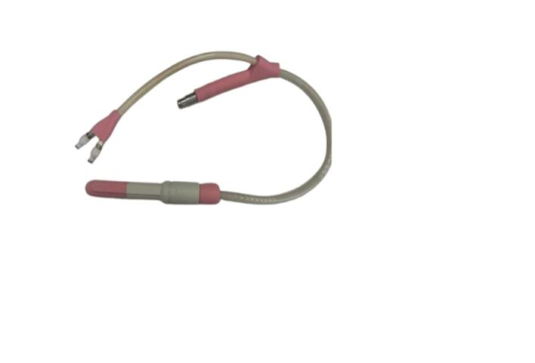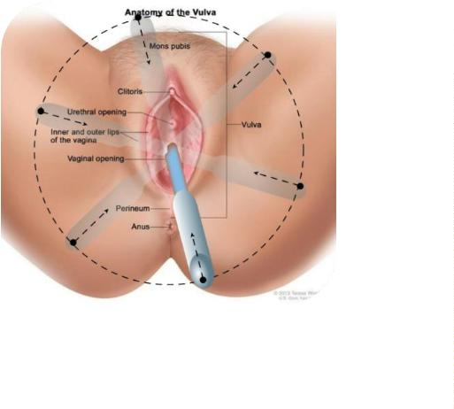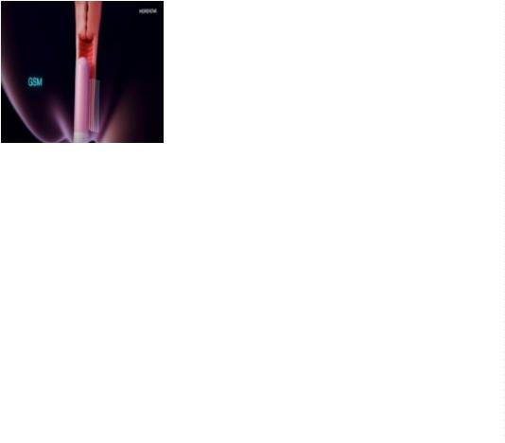

•
Clinicians should be familiar with this protocol and the "Instructions for Use" provided
by the manufacturer.
Checklist for Each Session:
•
•
•
Conﬁrm that the patient meets the inclusion criteria and has no contraindications.
Ensure the device and Transducer are clean, sanitized, and function correctly.
Verify that the Transducer placement aligns with the speciﬁed anatomical area.
1
2. References
For clinical studies and additional resources, visit the Initia Clinical Data Center.

